**PRACTICAL-10**

**AIM**

Perform Live / Memory Analysis on a Linux OS and prepare a detailed report.

**IMPLEMENTATION**

* Step 1: Download from <https://github.com/504ensicsLabs/LiME>

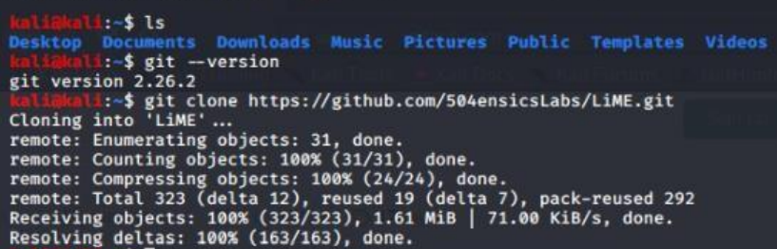

* Step 2: Now go to src folder in LiME and view the contents.

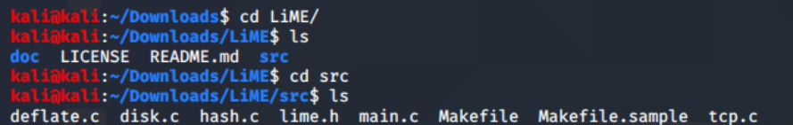

* Step 3: Now run the make command to compile it.

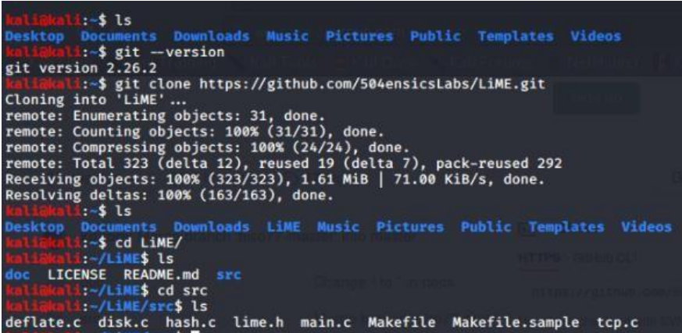

Step 4: Run the command “sudo insmod ./lime-5.5.0-kali2-amd64.ko “path= ../Linux64.mem format=raw”



Step 5: Creating a hash value for the memory image i.e., of Linux64.mem.

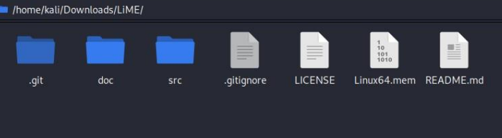

**CONCLUSION**

In this practical, we learnt to perform live analysis of memory in linux.